Train Now Fund
  - Grant Program Guidelines
  - ST070 February 2026

Contents
1. Aim 2
2. Funding available 2
3. Eligibility 3
3.1 Eligible applicants 3
3.2 Ineligible applicants 4
3.3 Eligible learners 4
3.4 Ineligible learners 4
3.5 Eligible expenditure 4
3.6 Ineligible expenditure 5
4. Assessment criteria 6
4.1 Supporting evidence 8
4.2 Learner support needs 8
5. Timeframes 9
6. Contact details 9
7. How to apply 9
8. Calculating training subsidies 10
8.1 Government Subsidy Amount 11
8.2 Requests for subsidies higher than the Government Subsidy Amount 11
8.3 Employer and Eligible Learner contributions to the cost of training 11
9. Application assessment and funding allocation 12
9.1 Assessment 12
9.2 Funding allocation 14
10. Funding agreement, reporting and payments 14
10.1 Grant agreements for successful applicants 14
10.2 Training commencement and completion timelines 14
10.3 Reporting and payments 15
10.3.1 Reporting 15
10.3.2 Grant payments 15
10 Appealing a decision 15
11 Taxation and financial implications 16
12 Publicity of grant assistance 16
13 True and accurate information 16
14 Right to information 16
15 Information collection and usage 16
16 Disclaimer 17

Aim
The Train Now Fund (Fund) provides grants for Skills Tasmania eligible Registered Training Organisations (RTOs) to deliver nationally recognised training that meets:
- an immediate or unexpected industry or enterprise training need, and/or
- an immediate or unexpected learner training need in a particular region or for a particular cohort.
The Fund supports delivery of nationally recognised training and assessment services in qualifications, single unit and multi-unit skill sets (both custom skill sets and training packages skill sets) to existing workers and/or jobseekers. Training must commence within six months of the start of the funding agreement and there are specific requirements for completing learners in skill sets.
The Fund is intended to support training responses to rapidly changing needs and to complement the more strategic and longer-term funding provided under Skills Tasmania’s Building a Skilled Workforce program.
Strategically, the Fund aligns with the objectives set out in the Tasmanian Skills Plan by supporting vocational education and training (VET) and complementary activities that meet skills and workforce needs, and gets more unemployed and underemployed Tasmanians into meaningful training connected to jobs.
Responding to rapidly changing need
Improving the responsiveness of the training system to meet industry and business needs is a key commitment outlined in the Tasmanian Skills Plan and is reflected in issues raised in Industry Skills Compacts. Training providers say that grant funding rounds released only once or twice a year can make it difficult for them to respond to immediate or unexpected needs in between.
Many employers and businesses must deal with unexpected requirements such as new regulations, shifts in their external operating environment (including things like pandemic, war, market shifts, new technologies or disruptive approaches from competitors), or compliance audit requirements. There are also training needs in regions or for particular cohorts of learners to take advantage of emerging job opportunities.

Funding available
A total of $1 million in funding is available for 2025-26 and is available until funds are fully allocated.
A maximum request of $150,000 per application per purpose applies. Multiple funding applications for different purposes are permitted. (Note that delivering the same training product to a different client cohort is considered a different purpose).
Subsidy rates are set in accordance with the Skills Tasmania Policy Statement – Subsidy Policy (What we pay for training). Requests for subsidies higher than the Government Subsidy Amount may be accepted in exceptional circumstances and will be assessed in-line with the exceptions statement in the Policy.
The Fund is administered by Skills Tasmania, a division in the Department of State Growth that manages the Government-funded training and workforce development system in Tasmania in partnership with industry, training providers and employers, as set out in the Training and Workforce Development Act 2013 (the Act).

Eligibility

3.1 Eligible applicants
To be eligible for a grant you must:
- be a Skills Tasmania eligible Registered Training Organisation (eligible RTO includes a Skills Tasmania endorsed RTO or a TasVET Supplier RTO)
- have the qualifications, skill set/s and/or unit(s) of competency included on the RTO’s scope of registration for delivery in Tasmania
- be financially viable (Applicants must provide financial statements for 2022, 2023 and 2024. If you are yet to prepare FY2024 statements, you must provide management accounts from Xero, MYOB or equivalent)
- have a current contract of public liability insurance for at least $20 million for:
  - each individual claim; and
  - series of claims arising out of a single occurrence
Applicants must ensure that all eligibility requirements are met prior to submitting the application and for the duration of any subsequent funding agreement. If the eligibility criteria are not met, the application will be deemed ineligible and will not be assessed or considered for grant funding.
A financially viable entity is one that is not under external administration, is not being wound up, dissolved, or trading while insolvent nor where a liquidator has been appointed. To demonstrate financial viability the applicant must be able to demonstrate the ability to generate sufficient income to meet operating costs, debt commitments and, where applicable, to allow for growth while maintaining service levels.
Applications submitted by a third party will not be accepted without evidence of permission in the application.
Declarations
Eligible applicants are required to complete numerous declarations in the application form including:
- a declaration against the applicant eligibility criteria.
- a declaration that the applicant has read and will comply with:
  - the Skills Tasmania Learner Eligibility Policy
  - section 3.2.3 of the Tasmanian Government: RTO Grant Recipient Standard Conditions Manual - School Learner Status (Noting that Apprentice and Trainee Training Fund is exempt from this requirement).
- a compliance history regarding all RTO regulatory and funding contract obligations (across all jurisdictions).
- a general declaration at the end of the application form to ensure that all grant requirements are understood.
Consideration of applicant responses to all declarations will be incorporated into funding decisions.
You may be asked to provide information or documentation to support your eligibility claims, either as part of the application process, or after you have submitted your application. The information you provide may be subject to authenticity checks.
This program has limited funding. Not all eligible applications will receive a grant.

3.2 Ineligible applicants
TasTAFE is ineligible for funding under this Fund. Organisations are encouraged to contact TasTAFE directly to discuss options for TasTAFE to deliver training under its existing funding arrangements.
Tasmanian School based RTOs (Schools as defined in the Tasmanian Education Act 2016) are not eligible for funding under the existing Skills Tasmania funding arrangements.

3.3 Eligible learners
Eligible learners include:
- existing workers (employed on a self-employed, casual, part-time or full-time basis), and/or
- jobseekers (individuals out of work and individuals who are underemployed, which is defined as employed people who would prefer, and are available for, more hours of work than they currently have, including part-time workers).
Eligible learners:
- can undertake training in more than one qualification or skill set per round
- will be eligible for a training place regardless of their prior qualifications or statements of attainment, and
- will also need to meet any course specific essential entry requirements.

3.4 Ineligible learners
Learners are not eligible for a training place under the Train Now Fund if they are:
- are not a Tasmanian resident
- are currently enrolled at a Tasmanian school, as defined by the Education Act 2016
- are currently funded for the same training by another funding source
- are an apprentice or trainee with a current training contract, and
- do not satisfy the eligibility requirements outlined in the Learner Eligibility for Government Training Subsidies policy statement which covers:
  - eligible visa status
  - ineligible government employees
  - restrictions on RTOs training their own staff
Please review the Skills Tasmania Learner Eligibility Policy .

3.5 Eligible expenditure
Funding is available for the delivery of nationally recognised training and assessment services in qualifications and skill sets (including single units, custom skill sets, and skill sets listed in training packages) for existing workers and/or jobseekers.
The Fund is intended to subsidise training responses to rapidly changing needs and to complement the strategic and longer-term funding provided under Skills Tasmania’s Building a Skilled Workforce program. Rapidly changing needs is defined in this context as changes in circumstance which have occurred within the 6 months prior to making an application.
The training must meet:
- an immediate or unexpected industry or enterprise training need, or
- an immediate or unexpected learner training need in a particular region or for a particular cohort.
For clarity, an immediate or unexpected need is something that could not be considered business as usual, or something that could not reasonably form part of usual business planning processes.
Examples of an immediate or unexpected need include:
- New or recently identified regulations or requirements
- Remedial action required by an audit or review
- Unexpected shifts in external operating environments (including things like pandemic, war, market shifts, new technologies or disruptive approaches from competitors)
- Immediate or unexpected opportunities for a particular learner cohort (for example a new business opening and needing staff)
- Immediate or unexpected opportunities in a particular region.

The training must provide learners with the opportunity to strengthen and/or develop their skills,
knowledge and understanding of the industry that relates to their employment and to achieve the
outcome for a training product(s).

Online training delivery is an eligible activity for delivery to eligible learners. Where online delivery is
proposed, applicants must ensure that quality of service is maintained by:
- identifying and providing individual learner support
- addressing all training package requirements (including all practical and work placement
- aspects), and
- complying with the principles of assessment and rules of evidence embedded in the 2025
Standards for Registered Training Organisations or its successor.

RTO’s intending to deliver services online, must specify in their written response to assessment criteria
and supporting evidence, what percentage of the overall training delivery will be delivered online and
how the delivery methodology/ies will address training and assessment of practically oriented units of
competency.

3.6 Ineligible expenditure
The following activities are not eligible to be funded under the Train Now Fund
- Non-nationally recognised training
- Training that is expected to commence more than 6 months into the future
- Training that does not respond to an immediate enterprise, learner or industry level training need, or could reasonably be considered business as usual
- Planned training demand that is better serviced by the Building a Skilled Workforce Program.

Ineligible activities include any training that is aimed at addressing a known or systemic problem. The Train Now Fund is aimed at addressing immediate and unexpected needs and not issues that could be covered by longer term planning and/or is better aligned with Building a Skilled Workforce Program funding.

Assessment criteria
Applications that meet the eligibility criteria will be competitively assessed using the assessment criteria.
The SmartyGrants application form requires the applicant to address each criterion individually and to attach relevant evidence to support claims made in addressing the criterion.
Assessment criteria
Criterion 1 – Demonstrated immediate need – 45% | Sample evidence
Element 1A - How did you identify that the training was needed immediately and or was unexpected? | Evidence for this criterion may include (noting the list is not exhaustive, nor prescriptive):  - Letters from employer/s, industry groups, Regional Jobs Hubs supporting the need for the training and the number of training places requested.  - Records on the results of consultative processes.  - Official publications detailing new requirements  - Links to changes in legislation  - Verifiable data on workforce circumstances and or issues.  - Evidence of data analysis.  • Audit report/s from industry regulators.  • Verifiable data on workforce circumstances and or issues.
Element 1B - How did you determine the requested number of training places?
Criterion 2 – Alignment with Government  Priorities – 10% | Sample evidence
Element 2A – Which government priorities will you be addressing through the proposed training? (Your response should consider the Tasmanian Skills Plan, the Skills Tasmania Snapshot of Training Needs, and Priority Course List.  Training needs that are not explicitly covered in these documents will be considered where the immediate or unexpected need is clear. | Evidence for this criterion may include specific excerpts or reference to:  - Tasmanian Skills Plan  - Skills Tasmania Snapshot of Training Needs  - Skills Tasmania Priority Course list

Criterion 3 – Learner outcomes – 15% | Sample evidence
Element 3A – How do you intend to identify individual learner needs? (Your supporting evidence must demonstrate how you have done this previously). | Evidence for this criterion may include (noting the list is not exhaustive, nor prescriptive):  - Examples of:  - completed training support plans for individual learners.  - file notes detailing support activities implemented for individual students.  - changes made to individual support plans based on monitoring activities identifying a lack of progress.  - before and after test results showing learner improvement post support.  - Schedule/s showing the times and dates for additional support classes.  - Samples of qualifications held by RTO staff enabling the enhancement of learner support (e.g. counselling qualifications, foundation skills qualifications or similar).  - Contracts/agreements with third party support providers.  - NCVER Student Outcomes Survey Results.  - Summary of student responses to internal surveys.  Note that any evidence which includes a learner’s name must have the learners name redacted.  Note also that learner support needs are not limited to language, literacy and numeracy (LLN), as detailed in the section 4.2 below.
Element 3B – Once a learner's needs are identified, what will you do to support them? (Your supporting evidence must demonstrate how you have done this previously).
Element 3C – How do you monitor the support provided to ensure it is working for the learner? (Your supporting evidence must demonstrate how you have done this previously).
Element 3D – How do you intend to measure learner satisfaction? (Your supporting evidence must demonstrate how you have done this previously).
Criterion 4 – Employer and industry outcomes – 15% | Sample evidence
Element 4A – What strategies have you and will you implement to identify individual employer needs for the requested training products? (Your supporting evidence must demonstrate what has been implemented previously). | Evidence for this criterion may include (noting the list is not exhaustive, nor prescriptive):  - Populated needs analysis templates.  - Meeting minutes / notes.  - Examples of:  - industry consultation plans and summary of results.  - partnerships / collaboration.  - contextualisation.  - flexibility.  - Employer Quality Indicator data.  - Summary of employer responses to internal surveys.  - Summary of employer responses to independent third-party surveys contracted by the RTO.  - Membership to peak bodies.  - Quality indicator reports for employers.  - Holding positions in the governance structure of industry bodies.  - Attendance at industry events.  - Tables summarising changes made to service delivery (before and after status) based on industry feedback.  - Letters of thanks or recognition from industry bodies.
Element 4B – How have you and will you monitor and measure that what you have implemented is meeting individual employer needs? (Your supporting evidence must demonstrate how this has been done previously)
Element 4C – Which industry bodies do you have a relationship with and how has this influenced your training delivery? (Note that this criterion relates to industry bodies and not individual employers. Industry bodies in this context are defined as organisations whose membership is made up of numerous organisations with allied interests. Membership to the industry body can be free, or fee based).
Criterion 5 – Capacity to deliver – 15% | Sample evidence
Element 5A – How do you plan to enrol learners, deliver training and ensure successful completions (Is there a delivery schedule, timetable, project plan etc?) | Evidence for this criterion may include (noting the list is not exhaustive, nor prescriptive):  - Project plan/s.  - Training delivery schedule/s.  - Facilities and equipment list/s (appropriate for the specific training product and number of students)  - Staffing allocation plan.  - Risk management plan.  - Training staff skills/experience/qualification matrices.  Note that RTO’s do not have to own all of the facilities and equipment but must be able to demonstrate timely access to the required facilities and equipment for the specific training product and number of learners
Element 5B – What staff will be involved in setting up and delivering the proposed training? (What staff will be involved in recruitment of learners, administrative support, learner support and delivering training and assessment?)
Element 5C – How will you ensure appropriate facilities, equipment and resources are available for the number of learners being delivered to?
Element 5D – How do you intend to manage any barriers to achieving the training, assessment and support services delivery? (Do you have a risk management plan, or similar, for the program?)

4.1 Supporting evidence
Applicants are encouraged to attach evidence to support any claims made.
Where there is no evidence to support claims made or the information provided in the application, the assessment score will be affected.
Any evidence provided must be attached to the relevant criterion, should have a clear document title and be referred to in the text in the application addressing the related criterion.

4.2 Learner support needs
Skills Tasmania considers that learner support needs are split into two types of need. The first is educational support and the second is wellbeing support needs. Educational support requires tailored instructions strategies to support the learner’s engagement and progression through to successful completion of the training product.
Wellbeing support needs relate to providing services and resources to assist the learner’s physical, mental and emotional wellbeing. Examples of support strategies for each type of need are provided below, noting that the lists are not prescriptive or exhaustive:
- Educational support
  - tutoring
  - additional classes
  - customising resources
  - practice tests
  - regular touch points with delivery staff, checking progress
  - assistive technology
  - reasonable adjustments
  - delivering sessions on learning how to learn, and
  - Language, literacy and numeracy (LLN) support.
- Wellbeing support
  - referrals to external providers for things such as mental health, addiction, financial support, domestic violence, youth support networks etc
  - adjusting training delivery times to accommodate child rearing responsibilities
  - subsidising transport (cab charges, bus fares, courtesy bus etc), and
  - providing culture-specific or demographic-specific supports in their local community (e.g. youth support networks.

Timeframes
Description | Date/time
Fund opens for applications | 5 February 2026 2:00 pm
Fund closes | Applications can be submitted at any time before 31 December 2026 at 2:00pm, or until funds are fully allocated.  * Applications will not be accepted after the program closes.
Applications assessed and applicants notified | Within two (2) weeks of submission
No applications will be accepted after the closing date and time.

Contact details
For information about the Train Now Fund, contact:
- Grant Program Manager, Skills Tasmania
- TrainNowFund@skills.tas.gov.au
- 03 6165 6060

How to apply
Applications must be submitted using the SmartyGrants online grant management system.
Applicants must register with SmartyGrants before making an application. There is a Help Guide for Applicants available from Smarty Grants. This can be accessed via the SmartyGrants website at: https://applicanthelp.smartygrants.com.au/help-guide-for-applicants/ Applications will be assessed in order of receipt.
This is a competitive, merit-based process. Meeting the eligibility criteria will not automatically result in a successful outcome.
These are the steps:
1. Prepare: Read the Grant Program Guidelines before starting your application. The application
form is designed to help structure applicants’ responses to the eligibility and assessment criteria as set out in the Guidelines.

2. Start: The application form is available at
https://skills.smartygrants.com.au/TNFST070
One application is required per learner type (existing worker or jobseeker)
3. Confirm: Ensure all information and documentation is accurate and attached. You may not be able to change an application or provide additional information after you submit your application.
4. Submit: You will receive an email notification after you submit your application. Keep this notification as confirmation of your submission.
5. Assessment: Applications will be assessed by independent assessors.
6. Notification: We will notify you with the outcome of your application in writing.
The decision will be final, and applicants will not be able to re-apply with the same request.
You may be asked to provide information or documentation after you have submitted your application. You must provide this information within three working days, unless otherwise advised. Failure to provide the information within the timeframe may result in the application being unsuccessful. The information you provide may be subject to authenticity checks.
Unsuccessful applicants
Applicants will be deemed ineligible if they do not meet the applicant eligibility requirements.
Applicants will be deemed unsuccessful if they do not adequately address and evidence the assessment criteria or do not meet the minimum quality benchmark score.
Unsuccessful applicants will be provided with an opportunity to receive written feedback on their application

Calculating training subsidies
Applicants must use the Skills Tasmania – Subsidy Request Spreadsheet (SRS) to detail their funding request. The SRS file is available within the SmartyGrants application form and must be uploaded with your application.
Instructions on how to use the SRS are available in the file. If you require support for this element of your application, please contact the Grant Program Manager listed under section 6 (page 9).

8.1 Government Subsidy Amount
Skills Tasmania subsidies are set in accordance with the Skills Tasmania Policy Statement – What we pay for training (Subsidy Policy). This Policy Statement is for use by Skills Tasmania and for reference by RTOs applying for funding.
The Policy provides that Skills Tasmania subsidises training and assessment services to reduce the cost to learners and employers for the services provided by RTOs. This encourages greater levels of participation in training than would occur without government support.
The Government Subsidy Amount is the total amount in ($) that the Government will contribute towards the cost of training and assessment services per learner, which includes any applicable loadings. The Government Subsidy Amount is identified in the Subsidy Request Spreadsheet.
The Skills Tasmania Government Subsidy Amount is only one contribution towards the total cost of training. The actual cost of training and assessment services is expected to be met by the Government Subsidy Amount plus contributions from learners and/or employers.
A subsidy for a skill set is based on the qualification level the units are commonly packaged into. If the units in the skill set come from more than one qualification, the qualification from which most of the units are sourced determines the FOE. If there are a mix of units across multiple qualifications, the intent of the skill set, and the employer industry determines the FOE.
Applying set loadings
Set loadings are available to deliver to particular learner cohorts or locations. The loading types and rates are set out in the Subsidy Policy and in the SRS, applicants can select more than one applicable loading per training product as part of the application process.
When requesting location loadings, applicants are required to provide detailed evidence to support the increased cost of delivery, based on the location’s delivery setting. Applications for location loadings that are not sufficiently evidenced through the application process are unlikely to be approved.
Applicants need to be aware that successful applications for any loading types, including location loadings, will be reviewed by Skills Tasmania as part of our increased focus on monitoring RTO compliance with all contractual obligations. If approved, Skills Tasmania may require successful applicants to provide evidence of learners meeting the parameters of whatever loading has been approved.

8.2 Requests for subsidies higher than the Government Subsidy Amount
As the Government Subsidy Amount is only a contribution to the cost of training, requests for subsidies higher than the Government Subsidy Amount are treated as an exception. The exception instances are described in the Subsidy Policy and will not be considered without prior consultation with Skills Tasmania.

8.3 Employer and Eligible Learner contributions to the cost of training
The actual cost of training and assessment services is expected to be met by the Government Subsidy Amount plus contributions from learners and/or employers.
Applicants may charge learners fees for training and assessment services, but this is not mandatory. These funds are to be paid to the RTO directly.
It is expected that RTOs pass-through the benefits of any approved loadings by reducing any fees or charges for eligible learners by a comparable amount.
Any eligible learner contributions are considered separate to the Government subsidy contribution from Skills Tasmania.

Application assessment and funding allocation
Applications that meet the eligibility criteria undergo a two-stage process before a funding
recommendation is made to the General Manager-Skills and Workforce: first, an assessment against the assessment criteria, followed by the allocation of funding.

9.1 Assessment
The assessment process is conducted by independent assessors using a structured framework and scoring methodology that aligns with the assessment criteria and the weightings outlined in Section 4 of these Guidelines. This process is overseen by the Grant Program Manager.
Stage 1 of the assessment process is where each assessor independently evaluates every criterion for each application, employing the approved methodology and data recording tools.
An example of the scoring rubric used by each panel member is provided below.
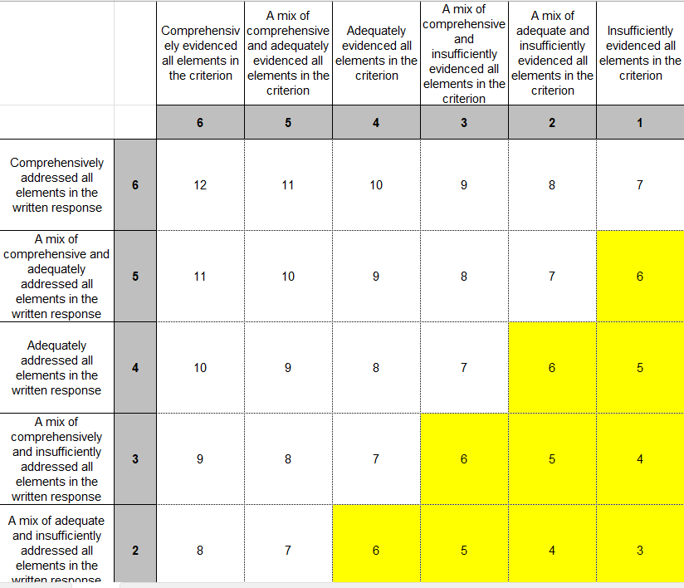
A benchmark score, representing an acceptable minimum standard of quality determined by the scoring rubric is then established by the selection panel. Applications that do not meet this benchmark are unlikely to be considered for funding. Those that achieve the benchmark score proceed to Stage 2 of the process (the funding allocation) for further consideration, although this does not guarantee funding of all training places requested.
Only those applications that achieve the overall minimum benchmark weighted score of 42, AND score a minimum raw score of 7 or above for assessment criterion 1 – Demonstrated immediate need, will be deemed successful.
Requests for subsidies higher than the Government subsidy amount are also scrutinised during the assessment process. The justification provided by the applicant is assessed using a decision-making tool aligned with the scoring rubric.
Skills Tasmania funding prioritisation framework
Applicants are most likely to be successful if they have demonstrated high-quality scores across
all assessment criteria and the training products they have requested align with Tasmania’s skills
priorities. The Snapshot of Training Needs provides an outline of funding priorities for Skills
Tasmania’s contestable grant programs and includes a guide to Government Funded Priority
Courses.
The assessment criteria for the Fund align with the two key components (summarised as ‘WHAT’ and ‘HOW’) of Skills Tasmania’s funding prioritisation framework (see Figure 1):
- ‘WHAT’ training will be delivered; how it aligns with industry, employer, learner and community needs and Government priorities; and the RTO’s capacity to deliver the training.
- ‘HOW training will be delivered – capturing training provider quality delivery and compliance (based on previous outcomes).
Applicants that can demonstrate high quality training delivery and propose to deliver training that
closely aligns with Skills Tasmania priorities and meets industry, employer, learner and
community needs, are more likely to score higher and be funded..
Figure 1: Skills Tasmania funding prioritisation framework
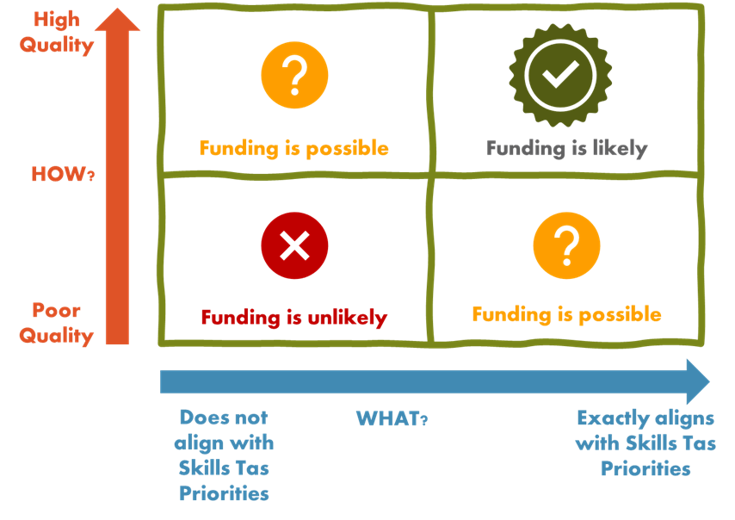

9.2 Funding allocation
Skills Tasmania aims to maximise public benefit and positive outcomes for the Tasmanian community in
each funding round. The funding allocation will consist of an equitable and diverse mix of applications
that align with Tasmania’s industry, regional and learner needs, underpinned by the quality standards
established by the assessment benchmarking process.
Given the finite availability of funding, there is no guarantee that every high-quality application offering
priority skills training will secure funding for the full number of training places requested. Skills Tasmania
reserves the right to offer applicants an adjusted number of training places, particularly in cases where
the demand for funding exceeds the allocated budget. Applicants may be offered a lower number of places where:
- multiple high-quality training providers request funding for similar training programs
- • a significant number of training places are being offered in one or adjoining regions
- • a single training provider has requested funding for an exceptionally large number of training
- places, and

Funding agreement, reporting and payments

10.1 Grant agreements for successful applicants
Applicants that are approved for a Train Now Fund grant will be required to enter into a Department of State Growth, Skills Tasmania Grant Deed (Training Services), on behalf of the Crown in Right of Tasmania. Breaches of a grant condition/s may lead to amendment or cancellation of the RTO’s grant agreement.
The details of all successful applicants will be published on the Skills Tasmania website.

10.2 Training commencement and completion timelines
Commencement
It is a condition of the Fund that training in skill sets and qualifications must commence within six months of the ‘training can commence from’ date. The ‘training can commence from’ date will be either the date the grant agreement is executed (the date the funding agreement is signed by Skills Tasmania), if that date falls within the allowable delivery period; or the date the allowable delivery period commences, if the grant agreement is executed prior to the allowable delivery period starting.
Completion
For skill sets, training must be completed within twelve months of the’ training can commence from’ date. This date will be identified in the funding agreement as the ‘date for completion of the approved purpose’ and will be 12-months from the date of execution of the funding agreement (the date the funding agreement is signed by Skills Tasmania), or 12-months from the date the allowable delivery period commences.
For qualifications, training must be completed within the volume of learning listed in the Australian Qualifications Framework. In the funding agreement, the date for completion of the approve purpose for qualifications will be 48 months from the date of execution of the funding agreement (the date the funding agreement is signed by Skills Tasmania), or 48 months from the date the allowable delivery period commences.
RTOs can apply to change the ‘training in all places must commence by date’ by submitting a request to the Train Now Fund email address: TrainNowFund@skills.tas.gov.au

10.3 Reporting and payments

10.3.1 Reporting
RTOs with a Department of State Growth (Skills Tasmania) Grant Deed (Training Services) are required to report training activity data to Skills Tasmania monthly.
The training activity data submitted by the RTO must be in accordance with the Australian Vocational Education and Training Management Information Statistical Standard (AVETMISS). This section of the Skills Tasmania website provides more information regarding reporting: Reporting my activity.
If an RTO receives funding for a custom skill set, this must be reported in the same manner as a Full Qualification or Training Package Skill Set (i.e. activity must be reported in both the NAT00120 and NAT00130). In order to facilitate reporting, Skills Tasmania will allocate a name and code for all custom skill sets, which is to be reported in the same way as a qualification code (e.g. CHC33015 - Certificate III in Individual Support). This means that custom skill set completions must be reported in the NAT 130, as well as the corresponding NAT 120

10.3.2 Grant payments
Grant payments are based on RTOs submitting validated AVETMISS learner activity data to Skills Tasmania. Details on payment arrangements can be found in the AVETMISS Payments, Reporting and VET Research and Evaluation section of the Department of State Growth (Skills Tasmania) Grant Deed (Training Services).
Payment arrangements for custom skill sets are identical to the payment structure for a full qualification.

Appealing a decision
If your application is unsuccessful, you may appeal the decision.
The appeals process ensures that all applicants have been treated fairly.
We will consider appeals that relate to administrative process issues in grants management.
All requests must be in writing and addressed to Director Purchasing, Policy and Programs. Your request must be received within 28 days from the date of State Growth notifying you of the decision about your application.
For further information about the process, contact the Grant Program Manager via email at TrainNowFund@skills.tas.gov.au or phone (03) 6165 6060.

Taxation and financial implications
Grants that deliver vocational education and training services are not subject to Goods and Services Tax (GST). For more information, contact the Australian Tax Office.
Grants distributed under this program may be treated as income by the Australian Tax Office (ATO).
We strongly recommend that, prior to applying, you seek independent advice from a tax advisor, financial advisor and/or the ATO, about the possible tax implications for receiving the grant.
Information on invoices can be found on our Business Tasmania website: www.business.tas.gov.au/manage_a_business/invoices

Publicity of grant assistance
State Growth is accountable for its spending of public funds, including providing grants. As part of the accountability process, State Growth may publicise, without further notice, information about the grants provided, including the level of financial assistance, the identity of the recipient, and the purpose of the financial assistance.
If you have received a grant from State Growth:
- despite any confidentiality or intellectual property right subsisting in the grant funding agreement or deed, a party may publish all or any part of the grant funding agreement or deed without reference to another party, and you consent to the disclosure of your name in this context.
- all obligations under the Personal Information Protection Act 2004 (Tas) still apply.
The details of all successful applicants will be published on the Skills Tasmania website.

True and accurate information
You must take care to provide true and accurate information. Any information that is found to be false or misleading may result in action being taken and grant funds, if already provided, may be required to be repaid to State Growth.

Right to information
Information provided to State Growth may be subject to disclosure in accordance with the Right to Information Act 2009.

Information collection and usage
Personal information will be managed in accordance with the Personal Information Protection Act 2004. This information may be accessed by the individual to whom it relates, on request to State Growth.
State Growth may use and disclose the information you provide for the purposes of discharging its functions under the Program Guidelines and otherwise for the purposes of the program and related uses. State Growth may also use information received in applications and during the delivery of the project for reporting purposes.

Disclaimer
Although care has been taken in the preparation of this document, no warranty, express or implied, is given by the Crown in Right of Tasmania, as to the accuracy or completeness of the information it contains.
The Crown in Right of Tasmania accepts no responsibility for any loss or damage that may arise from anything contained in or omitted from or that may arise from the use of this document, and any person relying on this document and the information it contains does so at their own risk absolutely.
The Crown in Right of Tasmania does not accept liability or responsibility for any loss incurred by an applicant that are in any way related to the program.

Department of State Growth
4 Salamanca Place
Hobart TAS 7001 Australia
Phone: 03 6165 6060
Email: TrainNowFund@skills.tas.gov.au
Web: www.skills.tas.gov.au/funding
Version 1 Published 5 February 2026

